Documentation of Deploymet Wechat

1. Do docker hub login on terminal

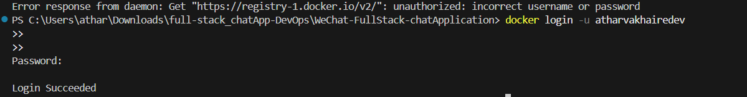

1. Start minikube

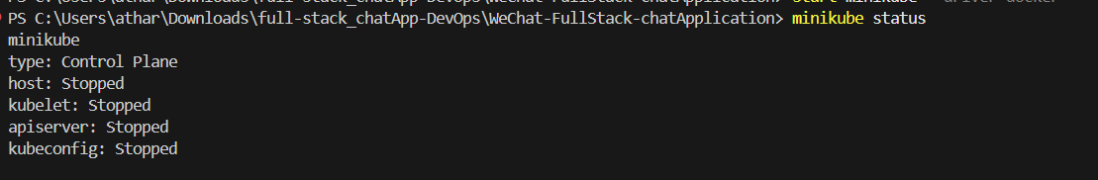



1. Created k8s folder for all kubernates yaml configurations

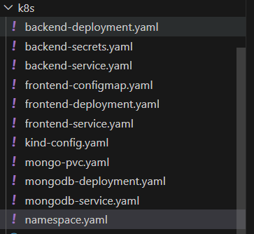

We need all this configuration.



1. Create build of frontend and backend both and push image to dockerhub
2. Running all deployments , services for backend , frontend and mongodb

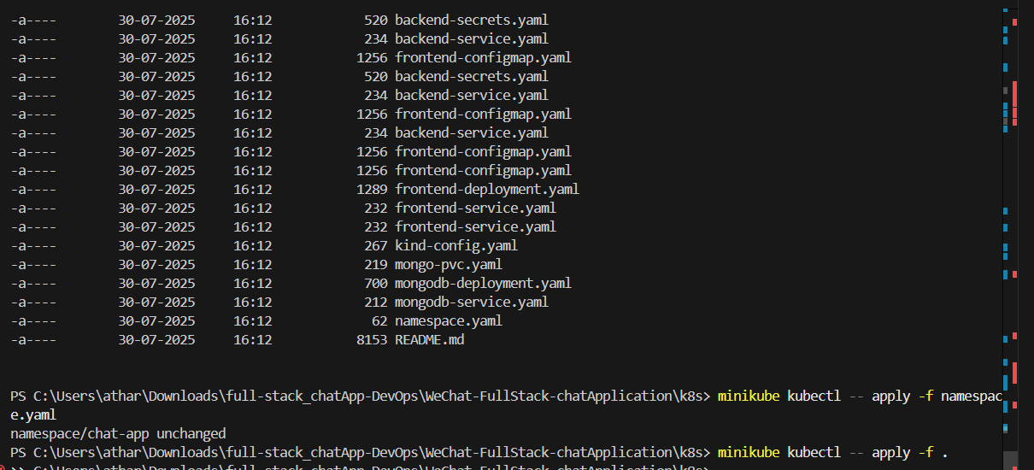

1. Now all pods are running

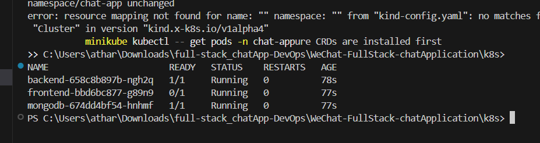

Look like this

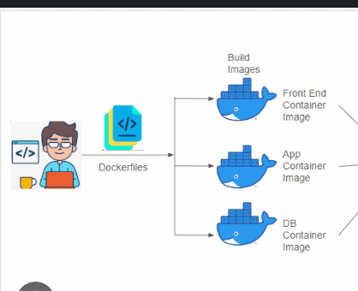

1. kubectl port-forward svc/backend 5001:5001 -n chat-app
2. kubectl port-forward svc/frontend 8080:80 -n chat-app
3. kubectl port-forward svc/mongodb 27017:27017 -n chat-app

Day 14-08-2025

Interview question for your applcaition with local host deployment on minikube with single cluster with single master and single worker node.

Q 1. Kyu humne multiple worker node lagte hai jab ki ek hi single node achhi machine ka le sakte hai?

Ans: Because if suppose who single machine down ho jaye toh humara pura ka pura server ya applcaition down ho sakta hai isliyee hum multiple node create karte hai.

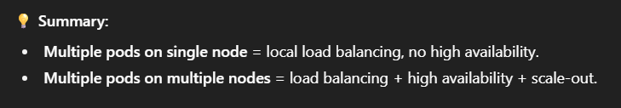

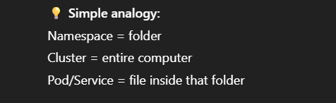

Pod ko ip kaise assign hota hai:

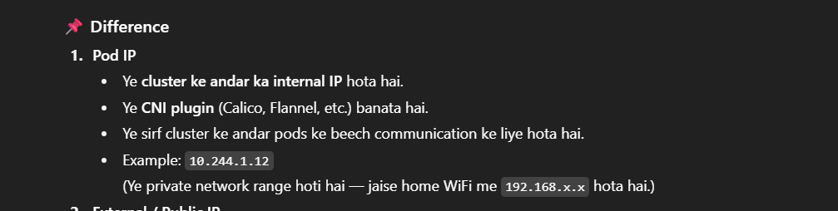

And that ip and load balancing of pod mangae by services .

Commands of minikube

minikube start

I have started minikube with docker driver I have done this without downloading vm because it will get heavy weight on my system.

minikube stop

to stop cluster

minikube add node

to add worker node on minikube

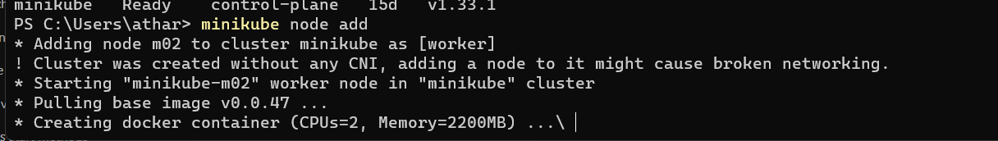

To delete created node

minikube node delete <node-name>

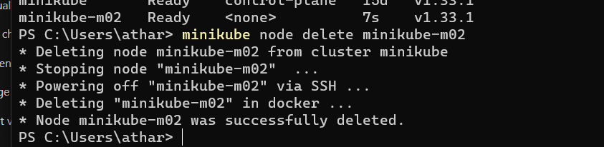

Created namespace using commands

Kubectl create namespace <name>

Kubectl get namespace

Kubectl delete namespace <name>